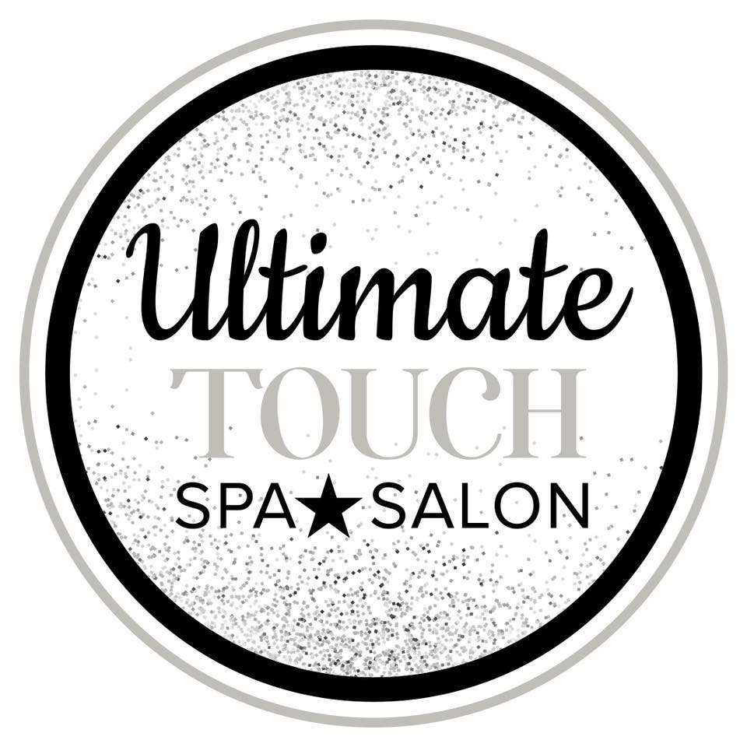
LASH EXTENSION CONSENT FORM
I understand that there are risks associated with having eyelash extensions
applied to or removed from my natural eyelashes. I further understand as part of the procedure that there is a potential possibility of an allergic reaction. Eye irritation, discomfort & watering eyes can occur. To prevent this, please advise your technician if you feel stinging during the application. We do not offer refunds for allergic reactions, but at no charge we will gladly remove the lashes.

I understand that before my appointment I should not wear any makeup,
especially mascara. Removing mascara can be time consuming & any residual
makeup will prevent proper application of the extensions. Also, removing mascara will cut into my appointment time & an additional fee will be charged to remove mascara & any leftover makeup.

I understand that I should not get my eyelashes wet within the first 12-24 hours
after application. I agree to use products recommended for my eyelash extensions to
ensure the longevity of the adhesive bond. I understand that if eyelash extensions are not properly cared for & cleansed on a daily basis that makeup, oil & dirt can build up causing irritation or infection.

I understand that I may request any look desired but if the eyelash extension
exceeds the natural lash length by more than double that there is a greater risk in
having temporary damage to the natural lashes.

I have been advised that using mascara on a daily basis will shorten the life
span of my eyelash extensions. As, the adhesive bond will begin to break down. If I
must wear mascara it has to be non waterproof & removed the same day applied. I understand that professional products will we recommended to better care for my lashes. I have also been advised not to use an eyelash curler on the extensions.

I understand that touch-up appointments may be necessary as soon as 2 weeks
after application & that there are additional fees for this procedure.

I _____________________________, authorize _____________________________________________
to apply eyelash extensions & products to my own natural eyelashes.

Client Name Print: _________________________________________Date: ______________

Client Name Signature: _________________________________________Date: ______________

87 East Main Street, Webster, MA 508-943-5751 www.ultimatetouchspa.com

