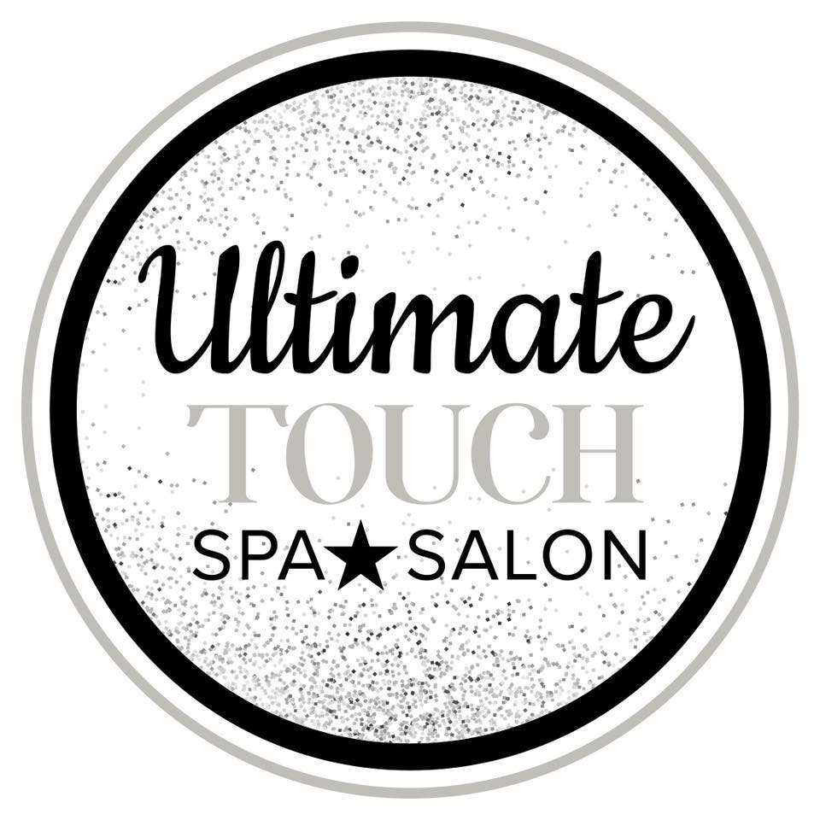
Eyelash Extension Aftercare
First 24 Hours
• Be gentle, avoid picking & touching
• Avoid water, heat, steam & tanning
• No makeup/mascara
• Sleep on your back or side
• Avoid anything oil based near the eyes

Long Term
• Do not rub or pick
• Sleep on your back or side
• Do not frequently visit sauna/steam room
• Do not use oil based cleansers/makeup/moisturizers
• Do not use eyelash curler
• Clean lashes daily with mild cleanser, avoid cotton.
Use index finger & ring finger or micro tip swabs.
• Brush lashes daily, when dry.

Mascara
Using mascara on eyelash extensions is NOT recommended,
as it will dissolve the adhesive bond. Constant use of mascara will
shorten the life span of the eyelash extensions.

If you must wear mascara, only use non-waterproof mascara.
We recommend use of our professional products specifically
suggested for lash extensions; including mascara and oil free
cleansing agents.

**If you decide to remove your eyelash extensions; do not attempt to
remove them yourself. Allow them to fall off naturally, or schedule an
appointment with an Ultimate Touch lash extension professional. **

87 East Main Street Webster, MA 508-943-5751 www.ultimatetouchspa.com

